4 Simple Steps to Recognizing Your Fellow Guiding Members!

Decide who you would like to nominate for awards, and which awards they should receive
- A simple overview of different awards can be found in the below pages

Find fellow Guiding members, girl members or parents to help provide supporting letters
- Most awards require two supporting letters in addition to a letter from the nominator

Fill out the Lougheed Area Awards Nomination Form as the nominator (click on the underlined words to access)
- Make sure that those who are supporting your nomination also fill out the form, and select that they are the supporters

Have the nominator fill out the R3 Awards form (accessed by double clicking the icon below) and email to awards@girlguideslougheedarea.org

For more information about awards, bursaries and informal recognition, visit https://www.girlguideslougheedarea.org/awards/ or email Carissa Konesky at awards@girlguideslougheedarea.org

All about our Guiding Awards

There are many ways that you can recognize that awesome Guiding member! See below for all the options that you have. Awards require one nominating letter and two supporting letters unless otherwise noted.

Recognizing a Unit Guider

Unit Guider Awards are presented to Guiders who help girls achieve greatness. The type of Unit Guider Award is presented based on the years volunteered as a Guider.

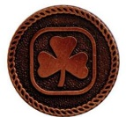
Bronze Unit Guider: 1-3 Years

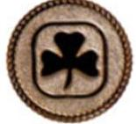
Silver Unit Guider: 4-10 Years

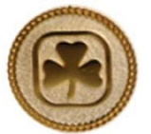
Gold Unit Guider: 11+ Years

Recognizing Members Who Go Above and Beyond

Merit Awards are presented to Guiding members who demonstrate dedicated, excellent, outstanding, and exceptional service above the basic requirements of the position held. Merit Awards are always awarded in order from Bronze to Gold. The Medal of Merit is only awarded to members who hold a Gold Merit.

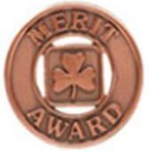
Bronze Merit: Awarded for dedicated service to Guiding (first Merit Award)

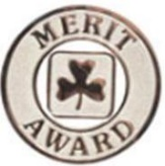

Silver Merit: Awarded for excellent service to Guiding (second Merit Award)

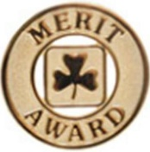

Gold Merit: Awarded for outstanding service to Guiding (third Merit Award)

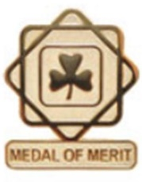

Medal of Merit: Awarded for exceptional service to Guiding (fourth Merit Award)

More Award Options

Please note that some of the awards below can be earned by Girl Members as well as Adult Members.

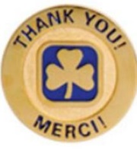
Gold Thanks Pin (can be given to Girl and Adult members): Given for exceptional service to Guiding and may be given more than once to the same person.
Please note that the Gold Thanks Pin does not require a nominating or supporting letter, only the R3 form should be given to the Awards Adviser. The Gold Thanks Pin can be awarded at anytime.
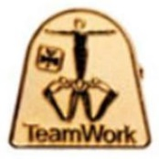
Team Award (can be given to Girl and Adult Members): Given to each member who has been part of a team that planned and carried to completion an extraordinary event or project. Cannot be awarded for carrying out standard Unit activities, it must be for a special event or project.
Please note that those providing nominating and supporting letters cannot be part of the team being nominated.
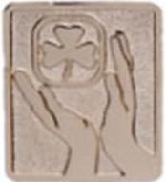
Commissioner Award: Given to Commissioners (including District, Area and Provincial) who lead by example, welcome and retain members, and uphold the values of Girl Guides of Canada.

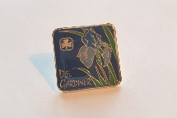
Lougheed Area Del Gardiner Award (can be given to Girl and Adult Members in Lougheed Area): Awarded to Lougheed Area members who show exemplary service and enthusiastic participation in Guiding, embody the Spirit of the Guiding Law, and continually give their best to Guiding.

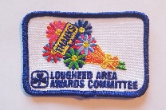
Lougheed Area Thanks Crest (can be given to Girl and Adult Members in Lougheed Area): Meant to be an easy and quick way to give appreciation for members who have done the little extras to help.
This award does not require supporting letters, only the R3 form sent to the Awards Adviser.

Provincial and National Awards

These awards require consultation with Provincial and/or National Councils. Please email the Awards Adviser if you are interested in nominating someone for these awards before you begin the process.

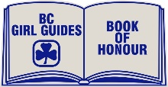
Book of Honour (Provincial Award): Awarded to an adult or youth member of Guiding
who has made a significant contribution to Guiding
Please note that three supporting letters and a minimum $100 donation are
required for this award.

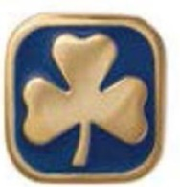
Honourary Life Award (National Award): Given to extraordinary members who usually have given at least 30 years of service to Guiding.
Please note that three supporting letters, a minimum $500 donation plus $150 pin and courier fee are required for this award.

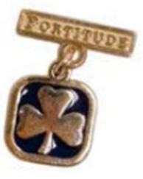
Fortitude Award (National Award, can be given to Girl and Adult Members): Granted by the Board of Directors to girl or adult members who have shown great courage and endurance in adversity.

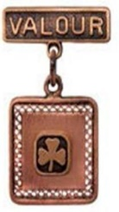
Valour Award (National Award, can be given to Girl and Adult Members): Granted by the Board of Directors to a girl or adult member who has shown heroism in risking her life or personal safety to save or attempting to save the life of another person.

